Table of Contents
Overview 2
Key Participation Rules 2
Problem Statement 2
Event Timeline 3
Submission Requirements 4
Judging and Pitching 5
Event Floor Plan 6
Event House Rules & Regulations 8
Ethical Consideration 10
Conflict of Interest 10
Contact and Support 10

Overview
Welcome to Build with AI MyHack Kuala Lumpur 2026, a premier 24-hour hackathon designed for innovators ready to push the boundaries of Artificial Intelligence. This handbook serves as your essential guide for navigating the event at Sunway University on May 16th to 17th, 2026.
Participants are expected to develop functional solutions addressing real-world challenges using advanced Google Developer technology, including Gemini 3.1 and Google AI Studio. Your work will be evaluated based on the official scoring rubric, which details the weightage for each criteria.
Success in this competition requires technical excellence, originality, and a clear focus on the chosen problem statement.

Key Participation Rules
All participants must adhere to the following eligibility and conduct guidelines:
- All project work must be completed during the hackathon duration.
- Professional behavior and academic integrity are mandatory.
For the full list of regulations, please refer to the MyHack T&C document available at:
Rules & Regulations

Problem Statement
You may find the full problem statement here:
Problem Statement MyHack 2026.docx.pdf

Event Timeline
Time | Activity
Day 1: 16/05/2026 (Saturday)
7.00 am - 8.00 am | Registration
8.00 am - 8.15 am | Opening Keynote by GDGKL
8.15 am - 8.25 am | Opening Keynote byJeff Sandhu, CEO @ 42 Malaysia
8.25 am - 9.00 am | House Rules Briefing & Domain Review
9.00 am - EOD | Breakfast and Hacking Starts
Day 2: 17/05/2026 (Sunday)
8.00 am - 9.00 am | Check In and Breakfast
9.00 am - 10.00 am | Hacking ends, hour of rest
10.00 am - 11.00 am | Talk Session by DevoTeam
11.00 am - 12.00 pm | Panel Session : Git Status - Checking Your Founder Readiness Before You Commit
12.00 pm - 12.30 pm | 42KL Sharing Session
12.30 pm - 1.00 pm | Finalist Announcement and Final Round Briefing
1.00 pm - 2.00 pm | Lunch Break
2.00 pm - 3.40 pm | Pitching Session 1 (Group 1 - Group 5)
3.40 pm - 4.00 pm | Toilet Break
4.00 pm - 5.40 pm | Pitching Session 2 (Group 6 - Group 10)
5.40 pm - 6.15 pm | Short Break and Networking Session
6.15 pm - 6.30 pm | Closing Keynote by CradleFund and Google
6.30 pm - 6.40 pm | Feedback Sharing by Judges
6.40 pm - 7.00 pm | Result Announcement
7.00 pm - 7.30 pm | Photo Session and Event Dismissal

Submission Requirements
Submissions for the Preliminary Round will be made via Google Forms and close on 17 May 2026, 9am.
Your submission MUST contain the following components:
- Presentation slides (PDF) showcasing the AI-driven solution based on the problem statement.
- Pitching video presenting the team's innovative approach and UN SDG impact.
- Prototype link to a GitHub repository containing the functional code and technical architecture.
- Questionnaire answers addressing the judging criteria relevant to business innovation and scalability, which include:
  - An elevator pitch
  - Usage of the following technologies and their justification of impact:
    - Google technologies used, why these technologies and how they enhance the solution.
    - AI components / models used, why it's essential to the solution and ethical considerations addressed.
    - We also will ask about your solution’s overall tech stack, deployment approach and AI performance.
  - Problem statement alignment questions, like:
    - What is the targeted issue, how does your solution manage the issue differently, and what measurable improvements does the solution bring on the issue.
  - Business aspects of your solution, including:
    - Core features, primary stakeholders and beneficiaries
    - Proposed business and revenue models, scalability (technical and operational)
    - We also will ask about your solution’s current infrastructure and steps needed to take to bring it from prototype to production

Judging and Pitching
Only the top 10 teams will advance to the Finalist Pitching Session.
Each finalist team will have a 15-minute session (8 minutes Pitching + 7 minutes Q&A) with the judging panel.
Finalists are encouraged to refine their prototypes and focus on the technical implementation during their live demo.
NOTE
Refer to the detailed scoring rubrics provided by organizers for precise evaluation criteria Prelim Rubrics.pdf

Event Floor Plan
Main Area (Sunway University, Level 1)
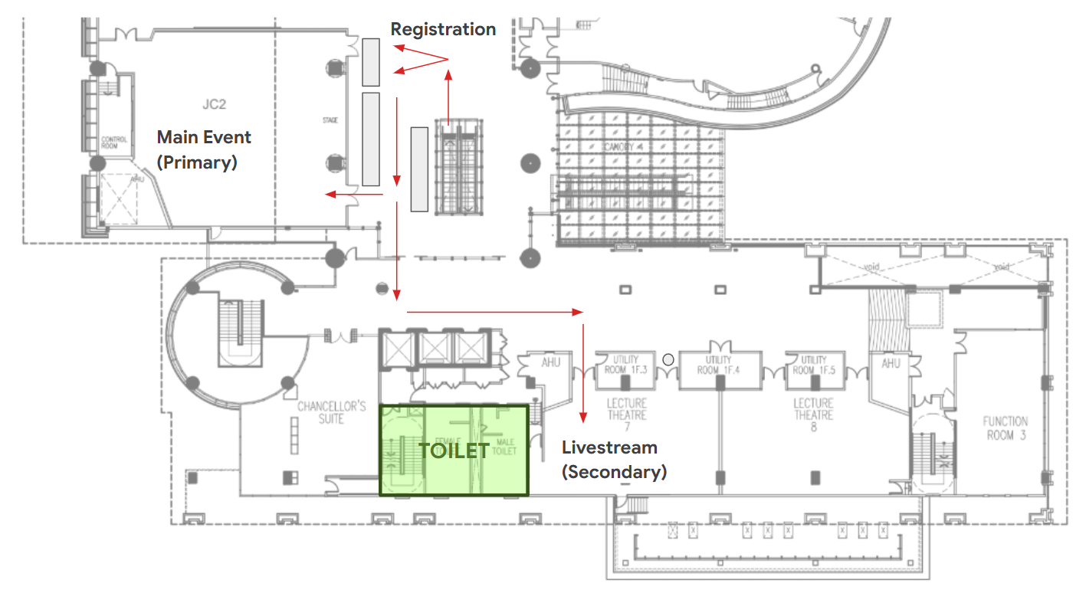
Sunway University ↔ Graduate Centre
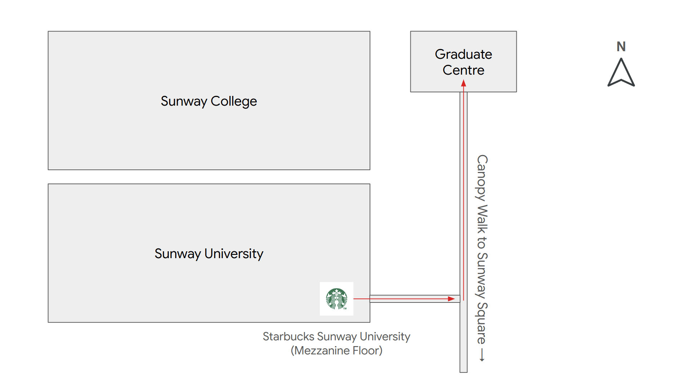

Hacking Area (Graduate Centre, Level 1)

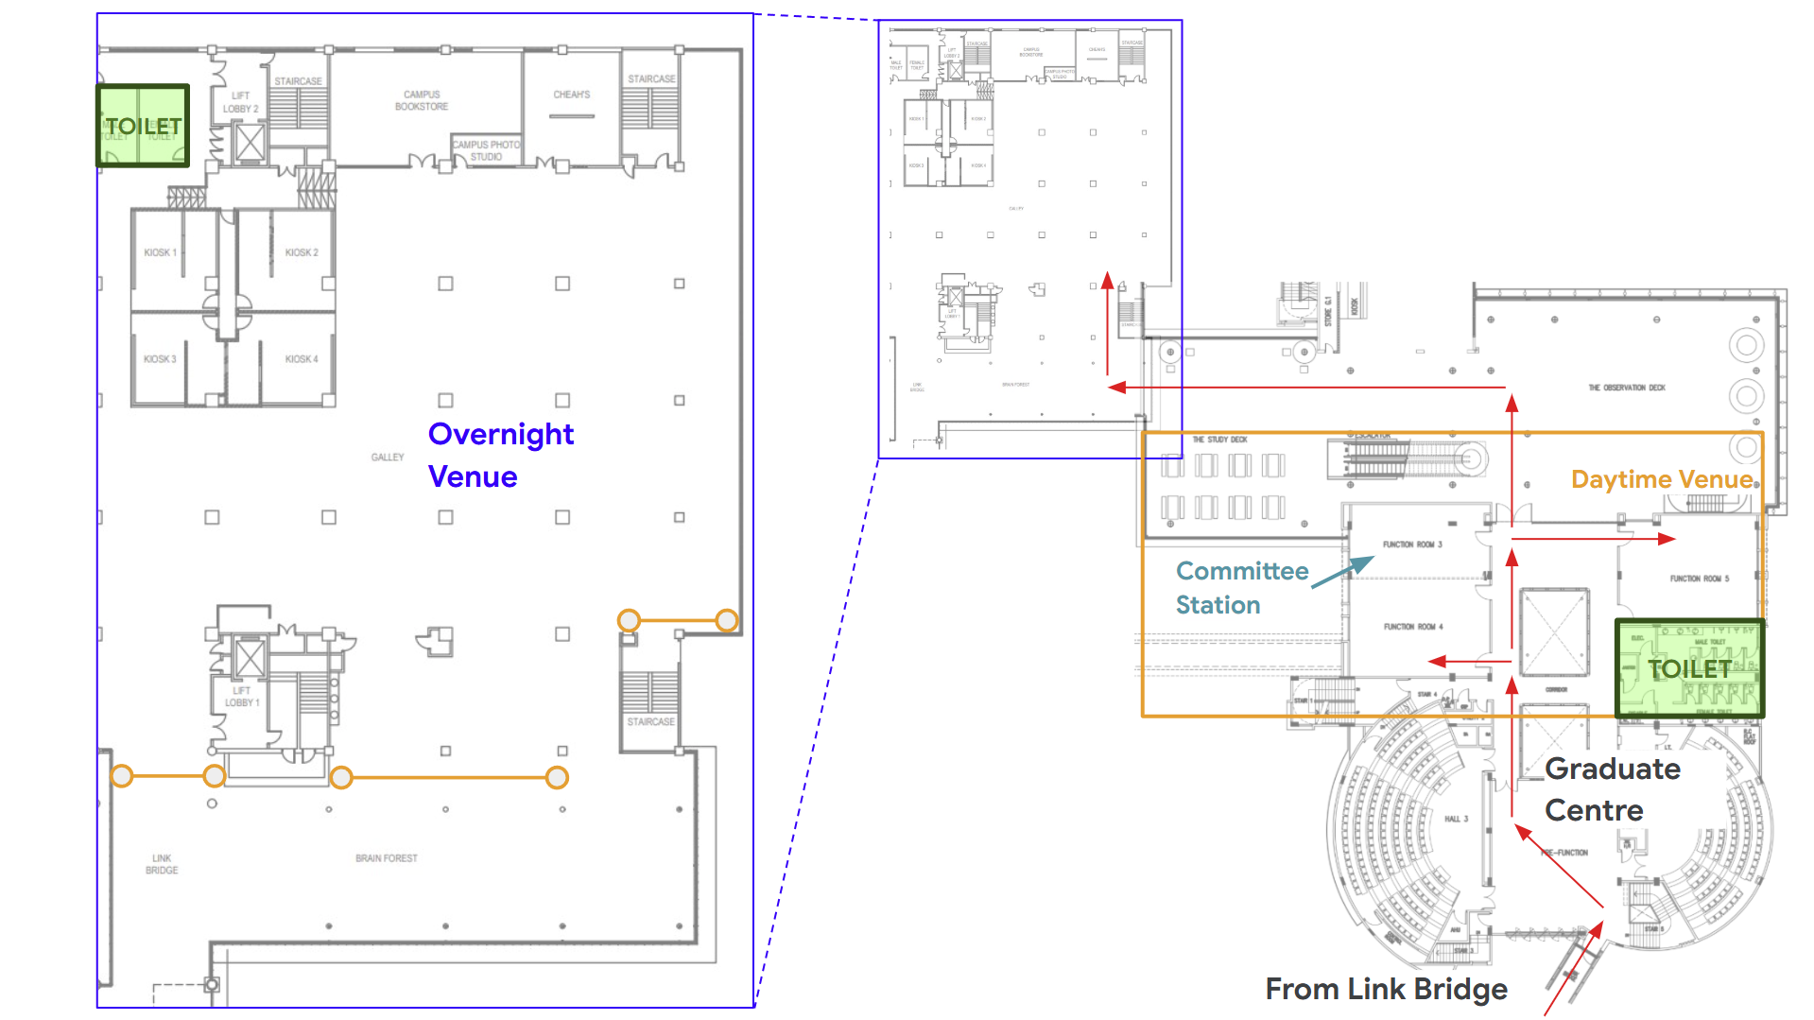

Event House Rules & Regulations
To ensure seamless event operations, participant safety, and a respectful environment for everyone, all attendees are required to comply with the following house rules and regulations throughout the duration of the event.
General Rules & Conduct
- Participants are required to wear or carry the official event lanyard at all times within the venue. Other forms of identification will not be accepted.
- Participants must comply with all instructions provided by the organizers, venue staff, security personnel, and emergency responders at all times.
- Participants are expected to behave respectfully and professionally throughout the event. Any form of harassment, violence, vandalism, disruptive behavior, unauthorized access to restricted areas, or violation of venue policies may result in immediate removal from the venue and/or disqualification from the event without further notice.
- Smoking, vaping, alcohol consumption, gambling, and the use of prohibited or illegal substances are STRICTLY PROHIBITED within the venue premises.
- Participants are expected to keep the venue clean and dispose of all waste responsibly before leaving the premises.
- Participants are responsible for the safety and security of their own belongings. The organizers and venue management shall not be held liable for any loss, theft, or damage to personal property.
- Participants must not tamper with, misuse, or remove any venue equipment, furniture, safety devices, or event property without authorization.
- Participants are required to comply with all venue rules, safety regulations, and applicable laws throughout the duration of the event.

Overnight Access & Quiet Hours
(Applicable between 10:00 PM and 7:00 AM)
- Participants staying overnight must remain within the designated overnight area between 10:00 PM and 7:00 AM, unless otherwise permitted by the organizers.
- As an alternative to staying overnight in the designated overnight area, participants may choose to return home or make their own accommodation arrangements before 10:00 PM during the overnight period if preferred. Participants who choose to do so are required to return to the campus (same area as the registration counter on 16 May) by 8:00 AM.
- Participants are expected to maintain a reasonable noise level during overnight hours to ensure a safe and comfortable environment for all attendees.
- In the event of a personal emergency or medical incident (e.g. feeling unwell, injury, collapse, or any health-related concern), participants are required to immediately notify the organizers or nearest event personnel to ensure prompt assistance and prevent further complications.
- In the event of an emergency at the venue, participants must remain calm and strictly follow all instructions issued by the organizers, security personnel, police, fire brigade, emergency responders, or any announcements made via the sound system or display screens. For safety reasons, participants may be required to evacuate or move to designated areas as directed by the relevant authorities.
- The organizers reserve the right to amend these rules and regulations at any time where necessary to ensure the safety, security and well-being of all participants.

Ethical Consideration
Participants must ensure all work is original and free from plagiarism. Suspected misconduct will result in immediate disqualification.

Conflict of Interest
If you have a prior relationship with any judge or organizer, please disclose this immediately. Integrity is vital for a fair and competitive hackathon environment.

Contact and Support
The organizing committee is here to support you throughout the 24-hour sprint. Reach out via Discord or directly to our leads:
Organizing Committee | Contact Number
Lai Min Han (GDG Kuala Lumpur Lead) | (+60)12-852 8433
Teoh Jia Yong (GDG Kuala Lumpur Co-Lead) | (+60)12-830 8785
Jonas Chuan (GDG Kuala Lumpur Program Team) | (+60)19-518 7978

